|  |  |
| --- | --- |
| **DOKUMENTASI EKSTERNAL**  External Documentation |  |
| **[TUGAS PROYEK]**  **[*Project*]** |
| **MATAKULIAH <COMP6115> – <Human and Computer Interaction >**  ***Subject*** |
| SEMESTER [GANJIL] 2019/2020 ***[Even] Semester Year 2019/2020*** |

## Judul Proyek

*[Assignment / Project]**Title*

* **RX Player Website**

## Pendahuluan

*Introduction*

Pembuatan **Project RX player**.

**RX player** is a digital music player company formed in December 2019 and located in Jakarta, Indonesia. The main purpose of the **RX player** is to provide millions of high-quality songs from any of the countries all around the world**. RX player** also provides all kinds of genres. Songs in **RX players** are always updated every day. The user can also be the creator that can upload their song to the **RX player** and share that song privately or publicly.

Lately **RX player** finds it is quite hard to handle the registration without an automatic system. To solve the problem, the **RX player** decides to create a website. The website can be used by the user as a listener or a creator. **RX player** also asked you to create a logo that represents their company. You as the chosen candidate of the new web designer is tasked to do those things.

## Dokumentasi

*Report / Documentation*

* **REPORT / PRINT SCREEN & DESCRIPTION**
  + **DETAIL 1**

**Home Page**

* Jika kita men -click gambar socmed yang ada pada bagian our social media dan footer maka akan redirect ke socmed ig, twitter & fb.

**JavaScript:**

* Jquery Image Slider

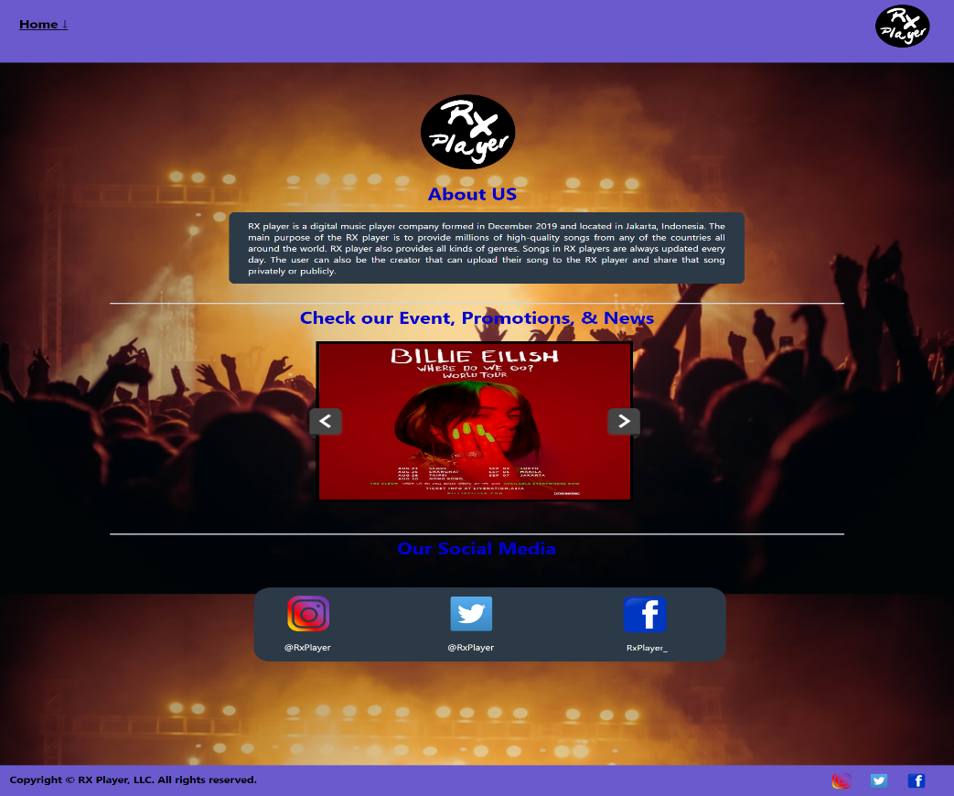

**Responsive ipad: 768 x 1024 (fit to window 50%)**

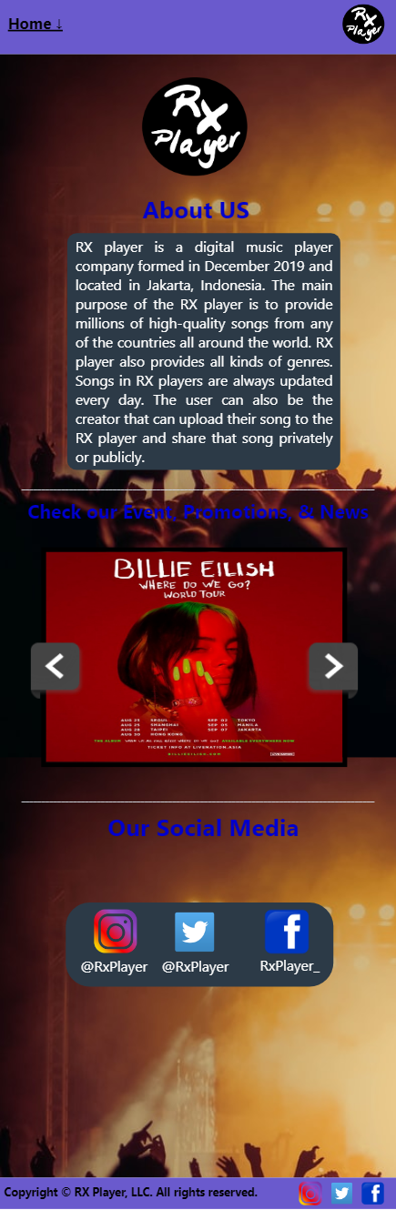

**Responsive iphone 6/7/8 plus: 414 x 736 (fit to window 82%)**

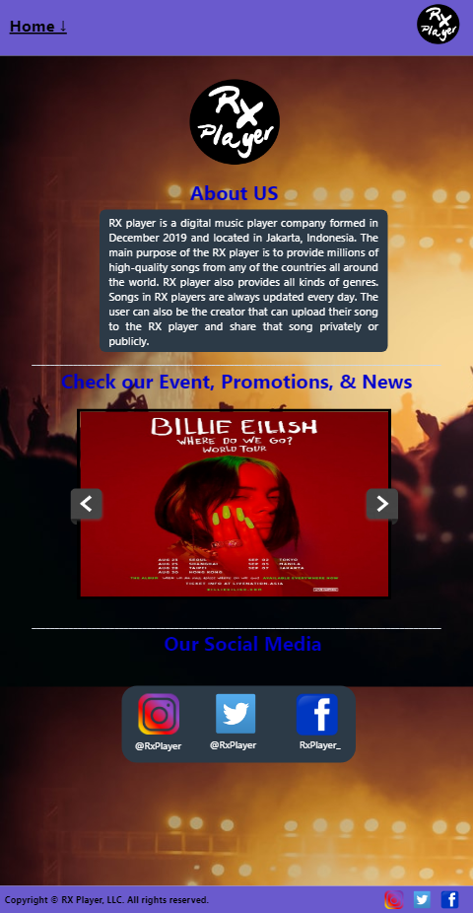

* + **DETAIL 2**

**Register Page**

- Button Cancel yang berfungsi untuk mereset form

- Gambar socmed footer maka akan redirect ke socmed ig, twitter & fb jika di click.

**Javascript:**

* Pada bagian **full name** adanya alert untuk validasi ‘Please fill your full name’ jika nama nya kosong & validasi jumlah nama dengan minimal 8 karakter
* Pada bagian **email** adanya alert untuk validasi ‘Please fill your email’ jika bagian email kosong & validasi email harus mengandung ‘@’
* Pada bagian **password & confirm password** adanya alert untuk validasi ‘Please fill your password’ jika keduanya kosong & validasi alert ‘password did not match’ jika password tidak sama dengan confirm password.
* Pada bagian **gender** adanya alert untuk validasi ‘Please select your gender’ jika tidak mengisi gender
* Pada bagian **agree terms** adanya alert untuk validasi ‘Please check the box to agree our terms ’ jika tidak mengisi box terms.
* Jika menekan tombol **submit** dan success makan akan mereload page, jika menekan button **cancel** maka akan mereset register form nya sehingga menjadi kosong semua.

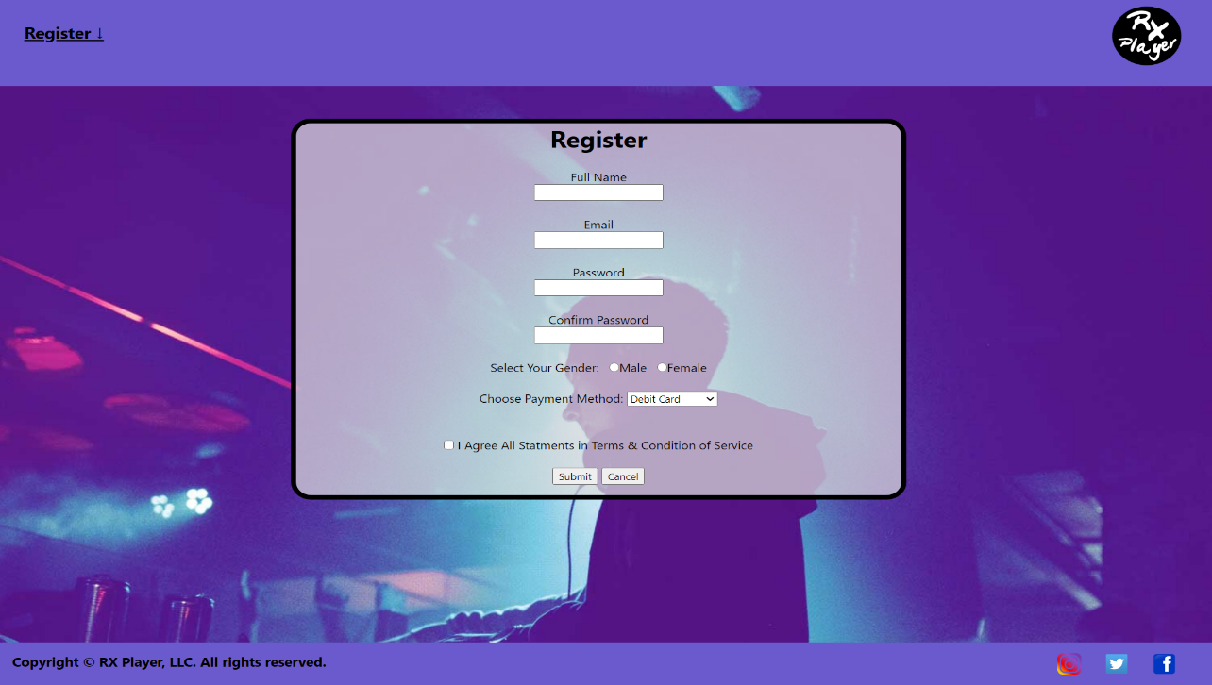

**Responsive ipad: 768 x 1024 (fit to window 50%) mohon maaf Jika blur di zoom saja word nya atau langsung ke html nya saja.**

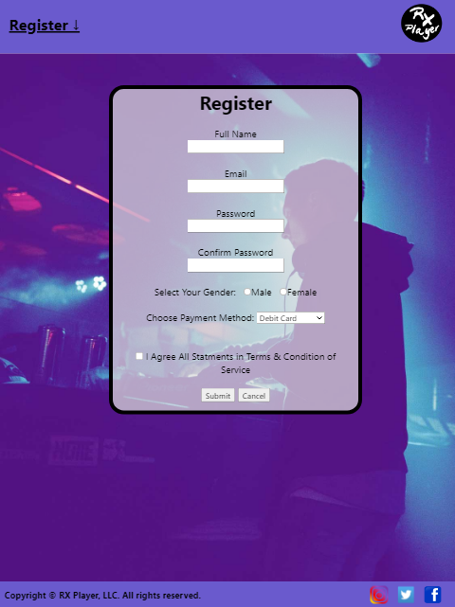

**Responsive iphone 6/7/8 plus: 414 x 736 (fit to window 82%)**

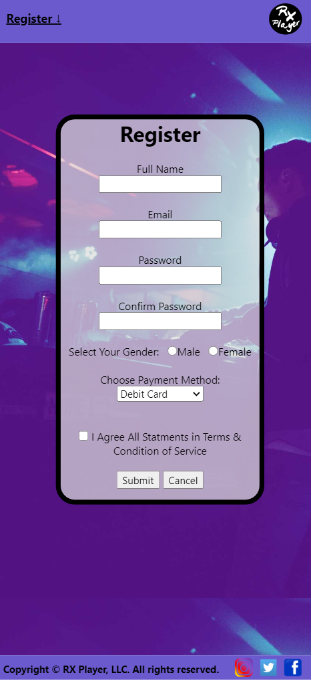

* + **DETAIL 3**

**Membership Page**

- Gambar socmed footer maka akan redirect ke socmed ig, twitter & fb jika di click.

- Pada button subscribe now yang akan ter-hover bewarna hijau jika mengarahkan cursor nya button tersebut.

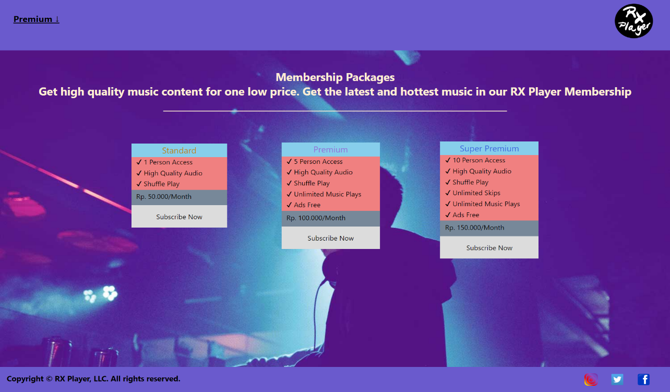

**Responsive ipad: 768 x 1024 (fit to window 50%) mohon maaf Jika blur di zoom saja word nya atau langsung ke html nya saja.**

**-** Abaikan background yang dobel karena itu merupakan bug extension ‘full page screen capture’ (sebaiknya cek di HTML nya langsung).

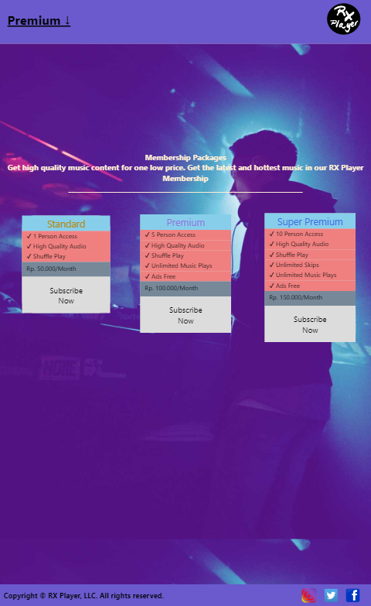

**Responsive iphone 6/7/8 plus: 414 x 736 (fit to window 82%)**

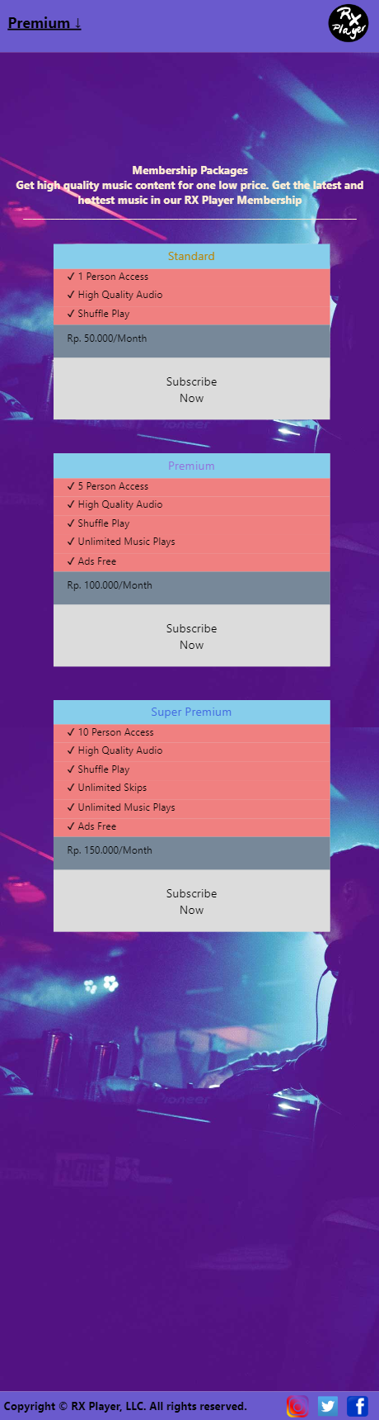

* + **DETAIL 4**

**Top 10 Asian Music Page Abaikan background yang dobel karena itu merupakan bug extension ‘full page screen capture’ (sebaiknya cek di HTML nya langsung).**

- Gambar socmed footer maka akan redirect ke socmed ig, twitter & fb jika di click.

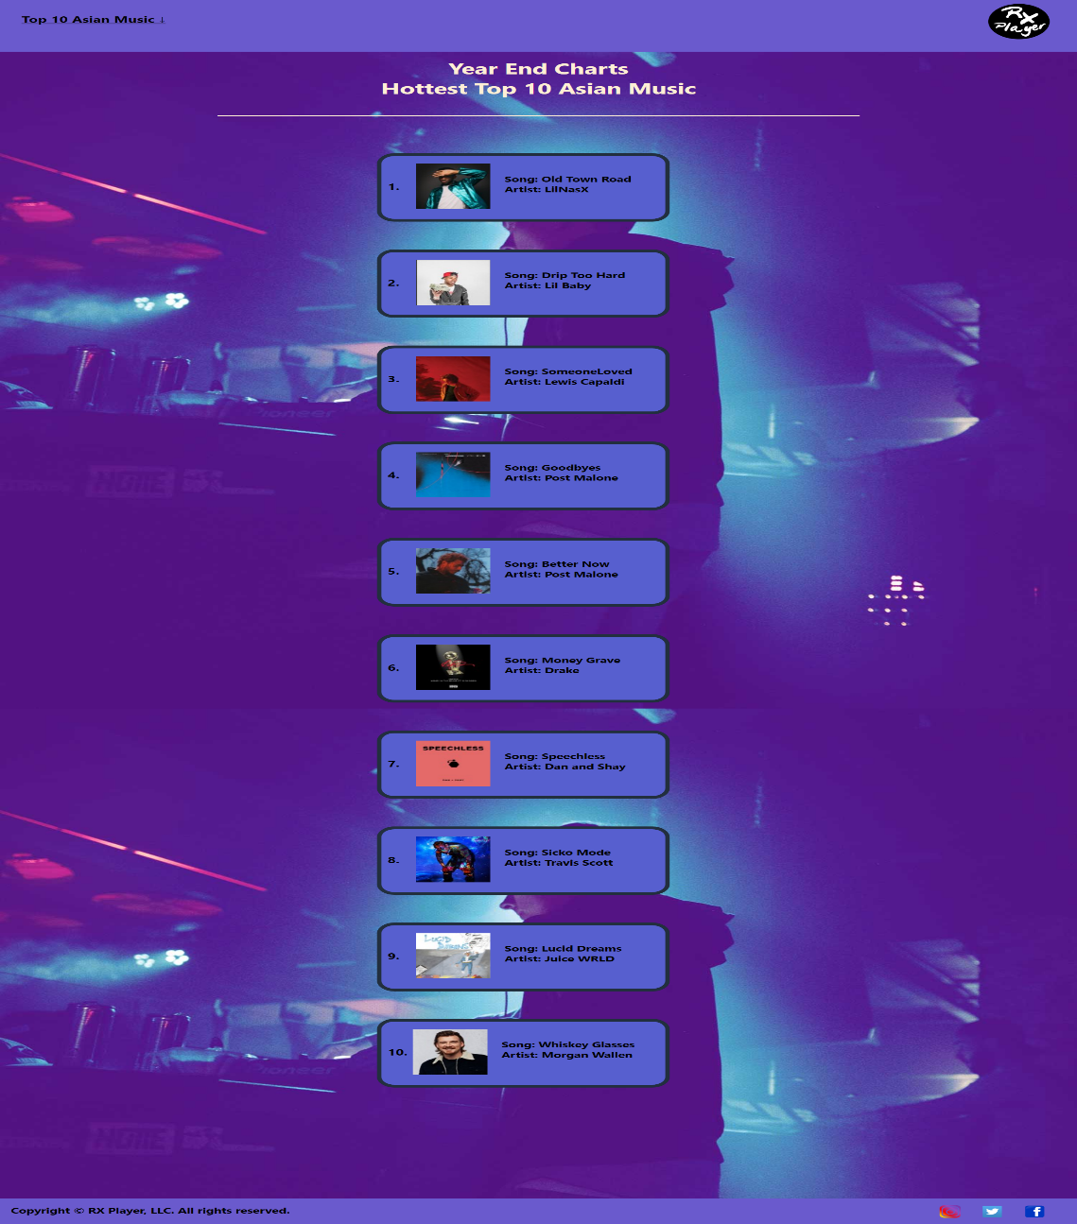

**Responsive ipad: 768 x 1024 (fit to window 50%)**

**Abaikan background yang dobel karena itu merupakan bug extension ‘full page screen capture’ (sebaiknya cek di HTML nya langsung)..**

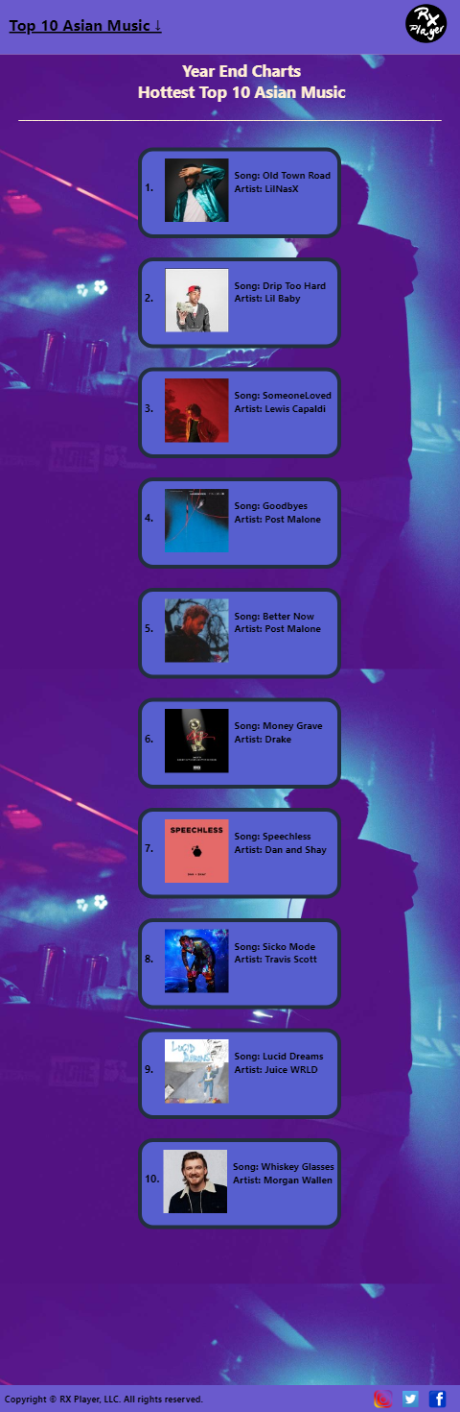

**Responsive iphone 6/7/8 plus: 414 x 736 (fit to window 82%)**

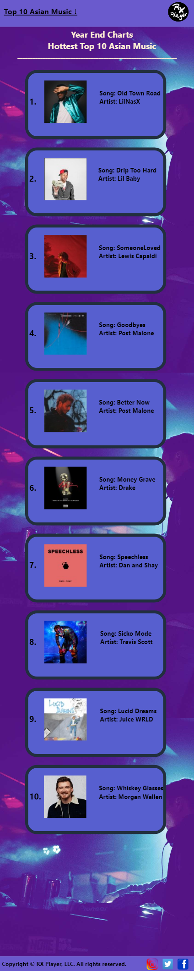

* + **DETAIL 5**

**Genre Music Page**

**Abaikan background yang dobel karena itu merupakan bug extension ‘full page screen capture’ (sebaiknya cek di HTML nya langsung).**

* Gambar socmed footer maka akan redirect ke socmed ig, twitter & fb jika di click.
* Kategori Jazz,Rock,Reggae,Classical yang akan terhover bewarna gold jika diarahkan cursor ke kategori tersebut.

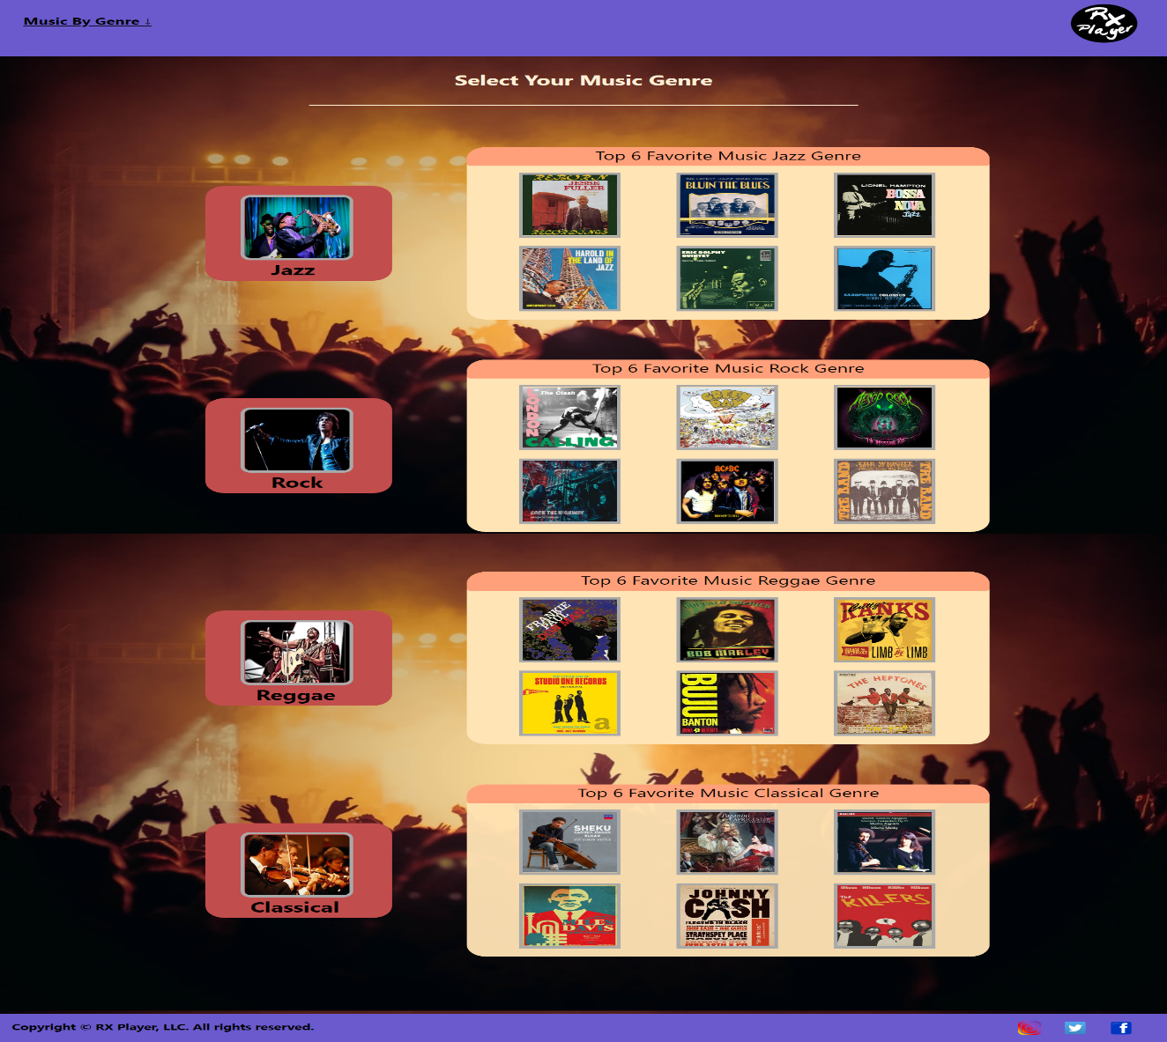

**Responsive ipad: 768 x 1024 (fit to window 50%)**

**Abaikan background yang dobel karena itu merupakan bug extension ‘full page screen capture’ (sebaiknya cek di HTML nya langsung).**

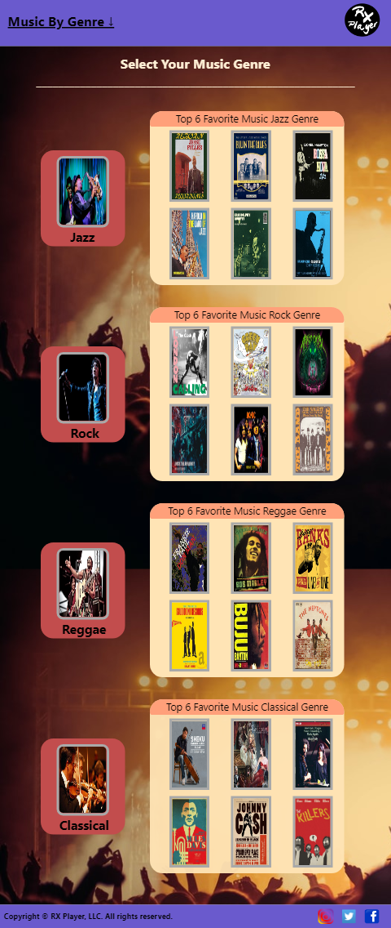

**Responsive iphone 6/7/8 plus: 414 x 736 (fit to window 82%)**

**Abaikan background yang dobel karena itu merupakan bug extension ‘full page screen capture’ (sebaiknya cek di HTML nya langsung).**

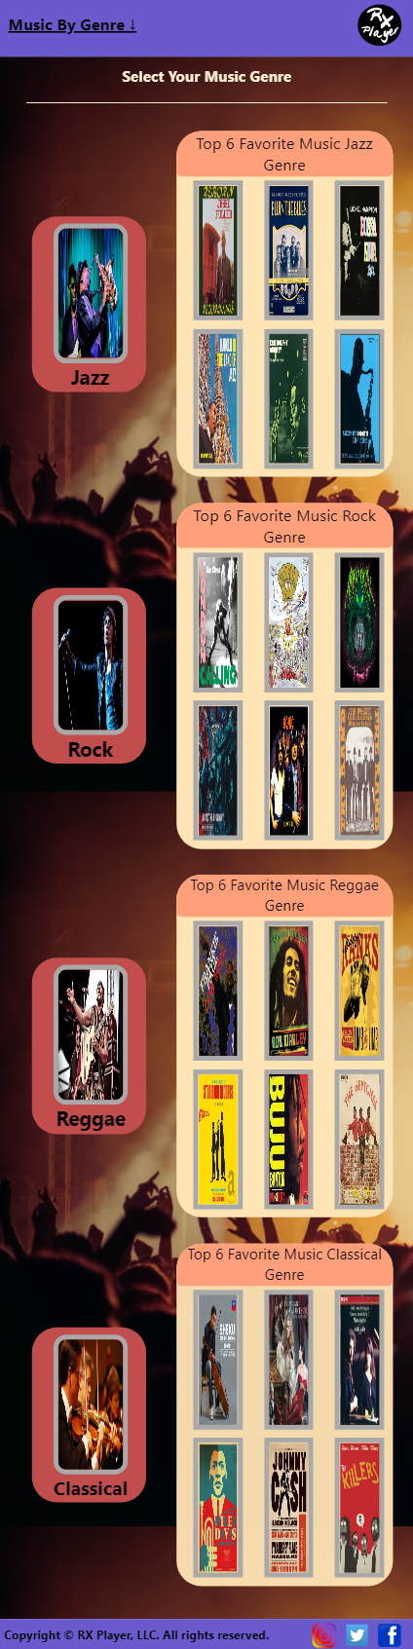

## Referensi

*References*

* **REFERENCES**
* **LINK**

Background:

* Backrground3:<https://audius.co/>
* Background1: <https://unsplash.com/photos/m1WZS5ye404>

TOP 10 MUSIC : <https://www.billboard.com/charts/year-end/2019/hot-100-songs>

Image Slider:

* Slider 1: <https://whatsnewindonesia.com/jakarta/event/billie-eilish-where-do-we-go-world-tour-live-in-jakarta/>
* Slider 2: <https://www.musicweek.com/talent/read/new-edition-of-music-week-out-now/076037>
* Slider 3: https://www.canva.com/design/DAD9mgKZakI/RQousz3O1fMJzohZsgz9mw/view?utm_content=DAD9mgKZakI&utm_campaign=designshare&utm_medium=link&utm_source=publishsharelink
* Slider 4: <https://www.jonesaroundtheworld.com/music-festivals-in-new-york/>

**Genre Music**

Jazz:

Genre 1 : <https://hot.liputan6.com/read/4008292/ciri-ciri-musik-jazz-dan-perkembangannya-dari-masa-ke-masa>

* Jazz 1: <https://br.napster.com/artist/jesse-fuller/album/jazz-folk-songs-spirituals-and-blues-hd-remastered>
* Jazz 2: <https://www.gettyimages.fi/detail/news-photo/sheet-music-cover-image-of-the-song-bluin-the-blues-the-news-photo/727070683>
* Jazz 3: <https://www.hungama.com/album/bossa-nova-jazz/28316420/>
* Jazz 4 : <https://www.amazon.com/Harold-Land-Jazz/dp/B000000Y9A>
* Jazz 5: <https://id.pinterest.com/pin/56506170318077188/>
* Jazz 6: <https://id.pinterest.com/pin/229261437265420326/>

Rock:

* Genre 2: <https://daman.co.id/styl-icon-mick-jagger/>
* Rock 1: <https://www.billboard.com/photos/6715351/best-album-covers-of-all-time>
* Rock 2: <https://www.amazon.com/Green-Day-Poster-Dookie-Perfect/dp/B07X6T3NYV>
* Rock 3: <https://genius.com/Aesop-rock-the-impossible-kid-album-art-annotated>
* Rock 4: <https://sleazeroxx.com/girish-and-the-chronicles-unleash-video-for-new-single-rock-n-roll-is-here-to-stay/>
* Rock 5: <https://www.nme.com/blogs/nme-blogs/acdc-what-next-for-the-band-after-malcolm-youngs-departure-19146>
* Rock 6: <https://www.discogs.com/The-Band-The-Weight/release/2977934>

**Reggae:**

* Genre 3: <http://www.mnialive.com/articles/icons-of-reggae-to-celebrate-jamaicas-50th-independence-anniversary>
* Reggae 1: <https://www.amazon.com/Don-Man-Frankie-Paul/dp/B00000043R>
* Reggae 2: <https://www.itl.cat/wallview/iioTwTm_these-wallpapers-are-available-to-download-for-free/>
* Reggae 3: <https://www.discogs.com/Cutty-Ranks-Limb-By-Limb/master/239913>
* Reggae 4: <https://www.amazon.com/Cover-Art-Studio-One-Records/dp/0955481775>
* Reggae 5: <https://en.m.wikipedia.org/wiki/Inna_Heights>
* Reggae 6: <http://www.hardformat.org/wp-content/uploads/2009/04/l_mg_7693.jpg>

**Classical:**

* Genre 4: <https://www.telegraph.co.uk/news/uknews/law-and-order/5916771/Classical-music-used-to-turn-away-graffiti-artists.html>
* Classic 1: <https://www.udiscovermusic.com/classical-news/sheku-kanneh-mason-elgar/>
* Classic 2: https://www.gramilano.com/2011/04/worst-classical-music-album-covers-ever/
* Classic 3: <https://www.wqxr.org/story/11-awkward-album-covers-80s-classical-edition/>
* Classic 4 :<https://id.pinterest.com/pin/437834395018357644/>
* Classic 5: <https://id.pinterest.com/pin/324329610660364943/>
* <https://id.pinterest.com/pin/350506783484568452/>

Disiapkan Oleh,

*Prepared by,*

*CLASS: BD-08*

* **<2201736971> - <Aldo Jonathan Handaka >**
* **<2201741971> - <Edward>**
* **<2201750105> - <Evan Edbert>**
* **<2201745534> - <Galuh Putra Warman >**